EX NO: 1
MULTI-PAGE STATIC WEBSITE USING SEMANTIC HTML5
18.10.2026

Aim
To create a multi-page static website named RootRise – Save Earth using HTML5, with separate pages for Home, Tree Planting Guide, Green Activities, and Registration, connected through navigation links.

Procedure
1. Create the Home Page (index.html)
Open Notepad and write the HTML code for the home page. Add the website title “RootRise – Save Earth”, the tagline “Growing a Greener Tomorrow”, navigation links, a welcome message, and information about protecting nature. Save the file as index.html.
2. Create the Tree Planting Guide Page (courses.html)
Write the HTML code to explain the steps involved in planting a tree. Use an ordered list (<ol>) to display the steps, such as choosing a place, digging a hole, planting a sapling, and watering it regularly. Save the file as courses.html.
3. Create the Green Activities Page (activities.html)
Write the HTML code to display activities that help protect the environment. Use an unordered list (<ul>) to show activities such as planting trees, saving water, avoiding plastic, and keeping the surroundings clean. Save the file as activities.html.
4. Create the Registration Page (register.html)
Write the HTML code to create a registration form for green volunteers. Include input fields for name and email, a selection list for activities, and Submit and Reset buttons. Save the file as register.html.
5. Add Navigation Links
Add navigation links to all four HTML pages using the anchor (<a>) tag. Use the <nav> tag to group the navigation links. This allows users to move between the Home, Tree Planting Guide, Green Activities, and Registration pages.
6. Add Headings, Colours, and Footer
Use heading tags such as <h1> and <h2> to organize the content. Add colours using CSS to create a light green background, dark green headings, and an attractive footer. Use the <hr> tag to separate sections and display the footer text “RootRise – 2026” on each page.
7. Save and Run the Website
Save all four HTML files in the same folder. Open index.html in a web browser and click the navigation links to check whether all pages open correctly.
Coding:
PROGRAM 1: HOME PAGE

<!DOCTYPE html>
<html>
<head>
<title>RootRise - Save Earth</title>
<style>
body {
font-family: Arial;
background: #eaf5e5;
color: #24552b;
text-align: center;
}
nav a {
margin: 10px;
color: green;
}
img {
width: 250px;
}
</style>
</head>
<body>

<header>
<h1>RootRise 🌱</h1>
<p>Growing a Greener Tomorrow</p>
</header>

<nav>
<a href="index.html">Home</a>
<a href="courses.html">Guides</a>
<a href="activities.html">Activities</a>
<a href="register.html">Join Us</a>
</nav>

<main>
<h2>Protect Our Planet</h2>
<img src="https://images.unsplash.com/photo-1448375240586-882707db888b"
alt="Green forest">

<p>Plant trees, reduce pollution, and
protect nature for future generations.</p>

<h3>Benefits of Trees</h3>
<ul>
<li>Provide oxygen</li>
<li>Reduce pollution</li>
<li>Protect wildlife</li>
</ul>

<a href="courses.html">Learn More</a>
</main>

<footer>
<p>© 2026 RootRise | Save Earth</p>
</footer>

</body>
</html>

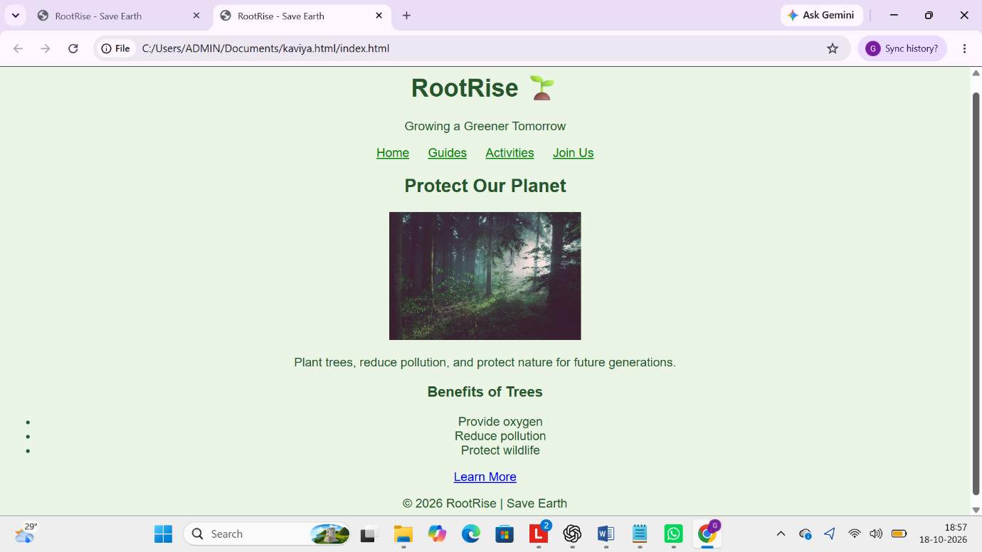
Output Screenshot 1 – Home Page

Program 2: Tree Planting Guide
<!DOCTYPE html>
<html>
<head>
<title>Tree Planting Guide</title>
<style>
body {
background-color: #eaf5e5;
color: darkgreen;
font-family: Arial;
text-align: center;
}
h1, footer {
background-color: forestgreen;
color: white;
padding: 12px;
}
a { color: green; margin: 5px; }
</style>
</head>
<body>

<h1>Tree Planting Guide</h1>

<a href="index.html">Home</a> |
<a href="courses.html">Guides</a> |
<a href="activities.html">Activities</a> |
<a href="register.html">Join Us</a>

<hr>

<h2>How to Plant a Tree</h2>

<ol>
<li>Choose a suitable place.</li>
<li>Dig a small hole.</li>
<li>Plant the sapling.</li>
<li>Cover the roots with soil.</li>
<li>Water it regularly.</li></ol>
<p>Trees give us oxgyen and protect nature.</p>
<footer>RootRise -2026</footer>
</body>
</html>

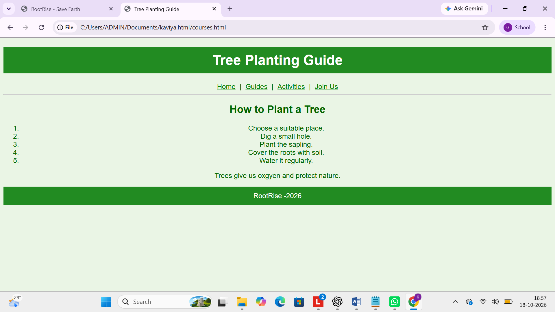
Output Screenshot 2: Tree Planting Guide

Program 3: Green Activities Page

<!DOCTYPE html>
<html>
<head>
<title>Green Activities</title>
<style>
body {
background-color: #eaf5e5;
color: #24552b;
font-family: Arial;
text-align: center;
}
h1, footer {
background-color: #2e7d32;
color: white;
padding: 15px;
}
a { color: green; margin: 5px; }
</style>
</head>
<body>

<h1>Green Activities</h1>

<a href="index.html">Home</a> |
<a href="courses.html">Guides</a> |
<a href="activities.html">Activities</a> |
<a href="register.html">Join Us</a>

<hr>

<h2>Activities to Protect Earth</h2>

<ul>
<li>Plant more trees.</li>
<li>Save water and electricity.</li>
<li>Avoid plastic bags.</li>
<li>Keep our surroundings clean.</li>
<li>Join clean-up drives.</li>
</ul>

<h2>Our Mission</h2>
<p>Small green actions create a healthier planet.</p>

<footer>RootRise - 2026</footer>

</body>
</html>

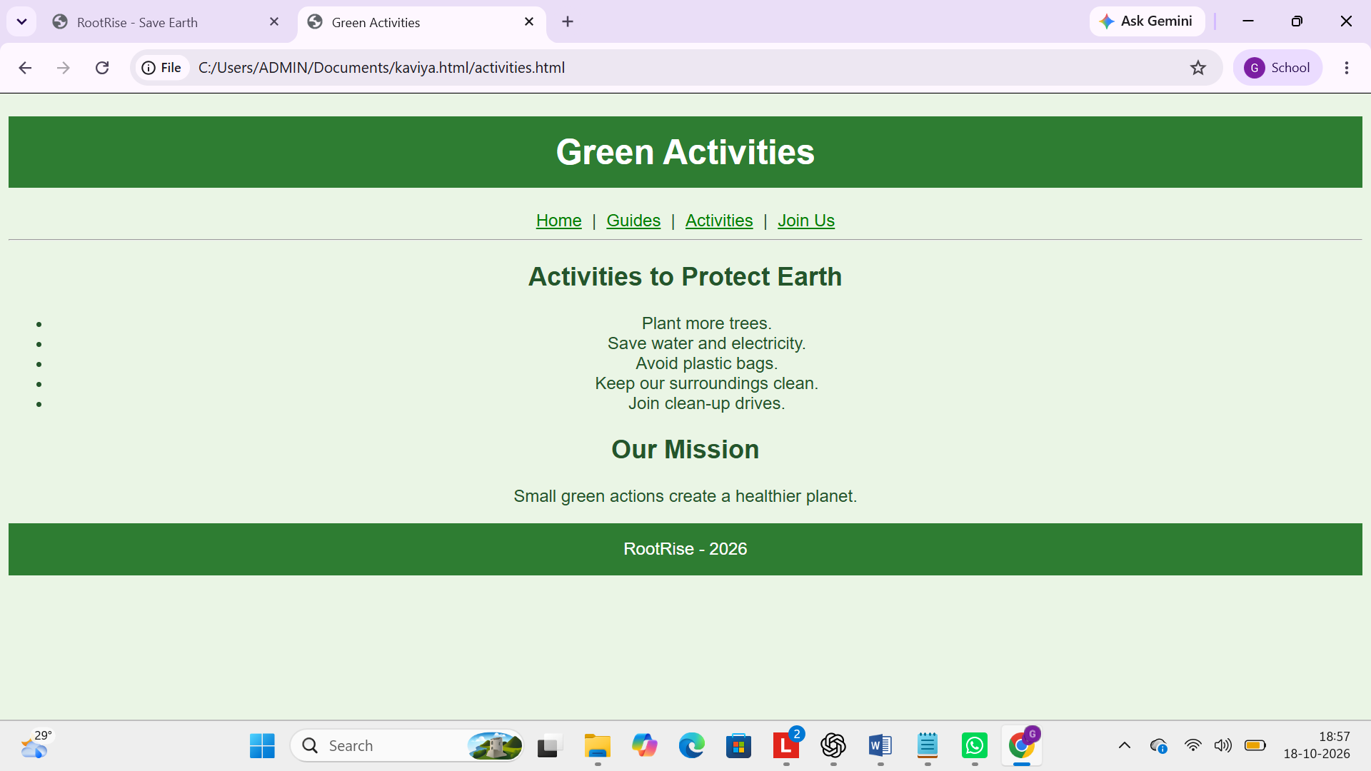
Output Screenshot 3:Activities page
Program 4 : Registration Page

<!DOCTYPE html>
<html>
<head>
<title>Join RootRise</title>
<style>
body {
background-color: #eaf5e5;
color: #24552b;
font-family: Arial;
text-align: center;
}
h1, footer {
background-color: #2e7d32;
color: white;
padding: 15px;
}
a { color: green; margin: 5px; }
</style>
</head>
<body>

<h1>Join RootRise</h1>

<a href="index.html">Home</a> |
<a href="courses.html">Guides</a> |
<a href="activities.html">Activities</a> |
<a href="register.html">Join Us</a>

<hr>

<h2>Become a Green Volunteer</h2>

<form>
<label>Name:</label>
<input type="text" required>
<br><br>

<label>Email:</label>
<input type="email" required>
<br><br>

<label>Activity:</label>
<select>
<option>Tree Planting</option>
<option>Cleaning Drive</option>
<option>Awareness Campaign</option>
</select>
<br><br>

<input type="submit" value="Join Now">
<input type="reset" value="Clear">
</form>

<p>Let's work together to protect Earth!</p>

<footer>RootRise - 2026</footer>

</body>
</html>

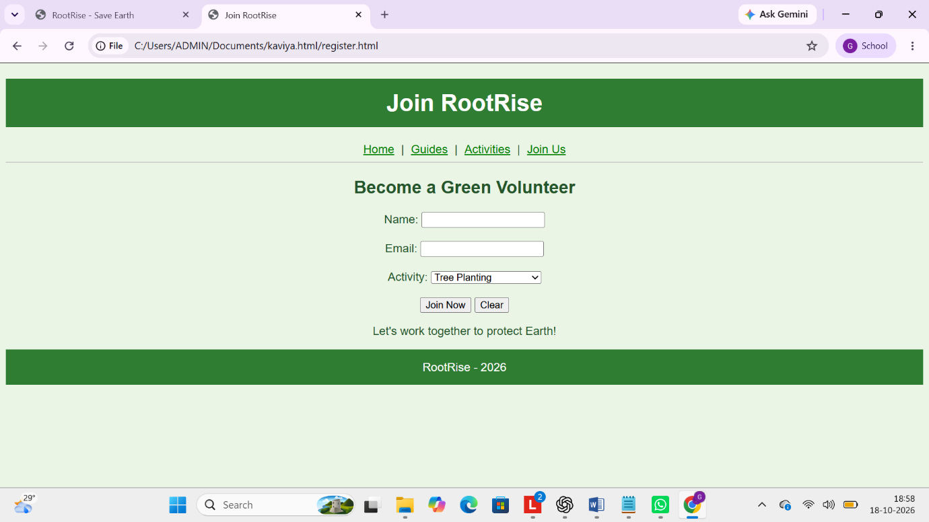
Output Screenshot 4: Registration Page

Result
Thus, a multi-page static website named RootRise – Save Earth was created successfully using HTML5 and CSS. Four pages were developed with navigation links, headings, lists, and a registration form. Colours were added to improve the website's appearance. All pages were tested in a web browser, and the navigation links worked correctly.

